KUBERNETES
Agenda
- Introduction
- Kubernetes in Data Engineering and DataOps
- Comparison with other Orchestration Tools
- Kubernetes Use Cases in DataOps
- Platforms that Support Kubernetes
- GKE
- Advantages of Using GKE
- GKE Console Overview
- Architecture of Kubernetes
- Monolithic Architecture of Kubernetes
Introduction to Kubernetes:
Kubernetes (often abbreviated as K8s) is an open-source platform designed to automate the deployment, scaling, and management of containerized applications.
Features of Kubernetes:
- Scalability: Kubernetes allows for seamless scaling of applications, ensuring they can handle varying loads efficiently
- Portability: Applications can run consistently across different environments, from local machines to cloud providers.
- Resource Optimization: Efficiently utilizes infrastructure resources, reducing costs and improving performance.
- Declarative Configuration: Enables infrastructure as code, allowing for version-controlled and reproducible deployments.
- Ecosystem Integration: Supports a wide range of tools and services, enhancing its capabilities and flexibility.
Kubernetes in Data Engineering & DataOps:
Kubernetes has become increasingly significant in the realms of Data Engineering and DataOps due to its ability to manage complex, data-intensive workloads.
Benefits in Data Engineering
- Orchestration of Data Pipelines: Manages the deployment and scaling of data processing tasks, ensuring reliability and efficiency.
- Environment Consistency: Provides consistent environments across development, testing, and production, reducing errors and discrepancies.
- Resource Management: Optimizes the use of computational resources, crucial for large-scale data processing.
Role in DataOps
- Automation: Facilitates automated deployment and management of data workflows, enhancing agility and reducing manual intervention.
- Monitoring and Logging: Integrates with monitoring tools to provide insights into data pipeline performance and health.
- Scalability: Easily scales data operations to handle increasing data volumes and processing demands.
Evolution: From Physical Servers → VMs → Containers → Kubernetes:
Understanding the evolution of infrastructure helps appreciate Kubernetes' role in modern computing.
Physical Servers
- Dedicated Resources: Applications ran directly on physical hardware, leading to resource underutilization.
- Limited Scalability: Scaling required adding more physical machines, which was time-consuming and costly.
Virtual Machines (VMs)
- Resource Isolation: Multiple VMs could run on a single physical server, improving resource utilization.
- Overhead: Each VM included a full operating system, leading to increased resource consumption.
Containers
- Lightweight: Containers share the host OS kernel, reducing overhead compared to VMs.
- Portability: Applications packaged with their dependencies can run consistently across environments.
Kubernetes
- Orchestration: Manages the deployment, scaling, and operation of containers across clusters of machines.
- Automation: Automates many aspects of application management, improving efficiency and reliability.
Comparison with Other Orchestration Tools:
Understanding how Kubernetes compares to other orchestration tools helps in selecting the right platform for specific needs.
Docker Swarm
- Ease of Use: Simpler setup and configuration, suitable for smaller applications.
- Scalability: Less scalable compared to Kubernetes, making it less ideal for large-scale deployments.
- Community Support: Smaller community and ecosystem compared to Kubernetes.
Apache Mesos
- Versatility: Designed to handle both containerized and non-containerized workloads.
- Complexity: More complex to set up and manage, requiring additional components like Marathon for container orchestration.
- Use Cases: Often used in environments requiring fine-grained resource allocation and support for diverse workloads.
Kubernetes
- Comprehensive Features: Offers a rich set of features for managing containerized applications at scale.
- Scalability: Designed to handle large-scale, complex deployments.
- Ecosystem: Extensive community support and a vast ecosystem of tools and integrations.
Kubernetes Use Cases in DataOps:
1. Scheduling Data Pipelines (ETL/ELT)
- ETL (Extract, Transform, Load) and ELT (Extract, Load, Transform) pipelines are essential for ingesting and preparing data for analytics and machine learning.
- How Kubernetes helps:
  - CronJobs in Kubernetes allow scheduled execution of ETL tasks.
  - Pipelines can be containerized and orchestrated across clusters using tools like Apache Airflow, Kubeflow Pipelines, or Argo Workflows.
  - Supports dynamic scaling of pipeline workloads based on demand or schedule.
  - Ensures high availability and retry mechanisms for failed tasks.
- Benefits: Automates and standardizes data workflows across environments; integrates well with CI/CD.
2. Running Batch Processing Jobs
- Batch jobs process large volumes of data in chunks, often outside of real-time constraints (e.g., log analysis, aggregation).
- How Kubernetes helps:
  - Use of Jobs and CronJobs for executing batch workloads.
  - Integration with Spark on Kubernetes, Dask, or Presto for distributed batch computation.
  - Native resource limits and affinity/anti-affinity rules to optimize job distribution.
  - Temporary containers can be spun up and torn down automatically, reducing costs.
- Benefits: Efficient, on-demand processing with fault tolerance and auto-recovery features.
3. Serving ML Models
- Deploying trained machine learning models to serve predictions via REST APIs or gRPC.
- How Kubernetes helps:
  - Tools like KServe, Seldon Core, or Kubeflow provide scalable models serving on Kubernetes.
  - Use of Horizontal Pod Autoscaler for scaling model serving pods based on incoming traffic.
  - Rolling updates ensure zero-downtime deployment of new models.
  - Integration with service mesh (e.g., Istio) allows A/B testing and canary deployments.
- Benefits: Scalable, reproducible, and easily manageable model serving infrastructure.
4. Managing Stateful Data Services:
- Running databases, message queues, or file systems that maintain state (e.g., PostgreSQL, Kafka, MinIO).
- How Kubernetes helps:
  - Kubernetes supports StatefulSets for managing stateful applications with stable network identity and persistent storage.
  - Persistent Volumes (PV) and Persistent Volume Claims (PVC) allow decoupling storage from compute.
  - Operators automate lifecycle management (e.g., backup, restore, scaling).
  - Supports cloud-native storage backends (e.g., EBS, Ceph).
- Benefits: Reliable state management in a dynamic, containerized environment.
5. Cost-Optimized Resource Scheduling:
- Efficient allocation and usage of resources (CPU, memory, GPU) to reduce costs.
- How Kubernetes helps:
  - Supports resource requests and limits to prevent resource contention.
  - Integrates with Cluster Autoscaler and Karpenter to scale nodes up/down based on workload.
  - Use of spot instances for non-critical jobs via taints and tolerations.
  - Custom schedulers or policies to allocate workloads to specific hardware types (e.g., GPU nodes for ML).
- Benefits: Reduces cloud costs while maintaining performance and reliability.
Platforms that Support Kubernetes:
On-Premise Platforms:
- kubeadm:A Kubernetes tool used to create production-ready clusters. Provides flexibility and control over the cluster setup but requires manual configuration and maintenance.
- Minikube: A lightweight Kubernetes distribution that runs locally on a single node. Ideal for developers and students to learn and test Kubernetes applications.
- MicroK8s: A minimal, low-footprint Kubernetes distribution developed by Canonical. Easy to install and use, particularly suited for IoT, edge computing, or development environments.
- Rancher: A complete container management platform that simplifies running Kubernetes across multiple clusters. Offers a user-friendly interface and centralized control for operations.
Cloud Platforms:
- Google Kubernetes Engine (GKE):A fully managed Kubernetes service by Google Cloud Platform. Offers seamless integration with other GCP services and is optimized for scalability and security.
- Amazon Elastic Kubernetes Service (EKS):Managed Kubernetes service by AWS. Allows Kubernetes clusters to run alongside other AWS services like EC2, S3, and IAM.
- Azure Kubernetes Service (AKS):Azure’s managed Kubernetes offering. Provides tight integration with Azure cloud services and supports enterprise features like Active Directory authentication.
- IBM Cloud Kubernetes Service:Fully managed Kubernetes clusters with built-in support for monitoring, logging, and DevOps tools.
- DigitalOcean Kubernetes:Developer-friendly, easy-to-deploy Kubernetes clusters. Known for its simplicity and cost-effectiveness.
- Oracle Cloud Kubernetes (OKE):A managed Kubernetes service that supports running enterprise workloads. Integrates with Oracle databases and applications.
GKE(Google Kubernetes Engine):
- GKE is a fully managed Kubernetes service offered by Google Cloud Platform.
- It abstracts away the complexities of cluster setup and management, allowing users to deploy and operate containerized applications efficiently.
- GKE supports both standard and autopilot modes. Standard mode gives more control over nodes, while Autopilot automatically manages node infrastructure for you.
- It provides features like automatic upgrades, auto-repair, horizontal and vertical pod autoscaling, and node pool management.
- GKE is deeply integrated with Google’s services and tools, making it a natural fit for data workloads and cloud-native applications.
Advantages of Using GKE:
- Fully Managed Service:GKE handles infrastructure tasks like provisioning, upgrades, and node health monitoring, reducing administrative effort.
- Integrated with GCP Services:Offers seamless integration with services such as BigQuery, Cloud Storage, Pub/Sub, Cloud Logging, and Cloud Monitoring, which are essential in DataOps workflows.
- Security:Built-in support for IAM, private clusters, workload identity, and VPC-native networking provides robust security.
- Scalability:Supports autoscaling of both clusters and workloads. Also enables GPU/TPU access for ML workloads.
- Ease of Setup:Cluster creation is straightforward via the GCP Console or command-line tools. Infrastructure as code (like Terraform) is also supported.
GKE Console Overview:
Search for Google Kubernetes Engine in GCP and then this will appear on your screen which is GKE on the console.
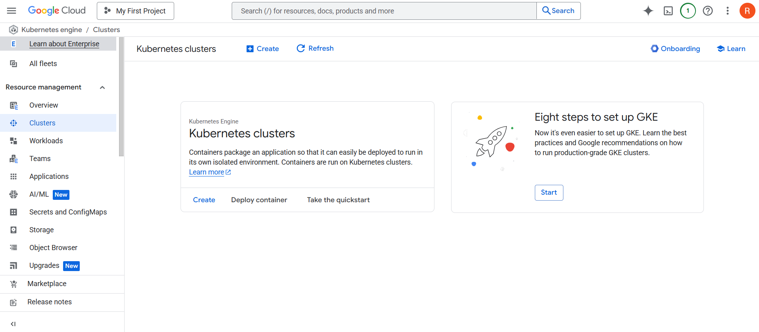
1. Kubernetes Clusters Overview (Main Panel):
This section offers three primary actions:
- Create: Launch the cluster creation wizard (Standard or Autopilot mode).
- Deploy container: Allows you to deploy a containerized app directly from a container image (like from GCR or Docker Hub).
- Take the quickstart: Launches a step-by-step tutorial for first-time users to quickly deploy and manage a GKE app.
2. Left Navigation Panel — Key Features:
A. Clusters
- Lists all your GKE clusters.
- You can create new clusters or manage existing ones.
- You can inspect health, version, node count, and configuration details.
B. Workloads
- Shows all deployed Kubernetes workloads (Deployments, StatefulSets, DaemonSets).
- Useful for monitoring app deployments and statuses.
C. Teams
- A management interface for organizing users and their roles (if using Google Cloud’s team-based features).
- Helps with access control and collaboration.
D. Applications
- Detects and displays higher-level applications and services deployed on GKE.
- May show things like Helm-managed applications or prebuilt apps from GCP Marketplace.
E. AI/ML
- Offers built-in AI/ML features and integrations with Vertex AI.
- Useful for deploying ML models into containers and scaling them with GKE.
F. Secrets and ConfigMaps
- Manage sensitive configuration (Secrets) and standard config data (ConfigMaps).
- Integrated with Kubernetes native kubectl commands.
G. Storage
- Persistent Volume Claims (PVCs) tab: Where pods request storage.
- Storage Classes tab: Defines types of storage (e.g., SSDs, standard disks) GKE uses for dynamic provisioning.
F. Object Browser
- File-system-like view to explore Kubernetes objects inside your cluster.
- Great for debugging and exploration without CLI.
G. Upgrades (New)
- Helps manage Kubernetes version upgrades.
- Provides insights into available cluster or node pool upgrades and GKE release channels.
H. Marketplace
- Lets you deploy pre-configured apps and stacks (like WordPress, MongoDB, NGINX) with a few clicks.
I. Release Notes
- Shows updates, feature rollouts, and changes in GKE services and APIs.
3. Top Bar Options:
- Search: Quickly find resources across GCP.
- Cloud Shell icon (>): Open an in-browser terminal preconfigured with gcloud and kubectl.
- Notifications (bell icon): System updates, alerts, or warnings.
- User Profile (circle with your initial): Account settings and project switching.
Architecture of Kubernetes:
In Google Kubernetes Engine (GKE), Kubernetes clusters are composed of a Control Plane and Worker Machines called Nodes. GKE abstracts and automates much of the infrastructure management, providing a managed Kubernetes experience.
- A GKE Cluster always consists of:
  - A Control Plane, which is fully managed by Google (in both Autopilot and Standard modes).
  - One or more Worker Nodes, which run user workloads (Pods).
- Users interact with the cluster using the kubectl CLI or via the Google Cloud Console.
  - kubectl sends requests to the Kubernetes API Server, which is hosted in the control plane.
  - The control plane makes scheduling decisions, maintains cluster state, and manages the worker nodes.
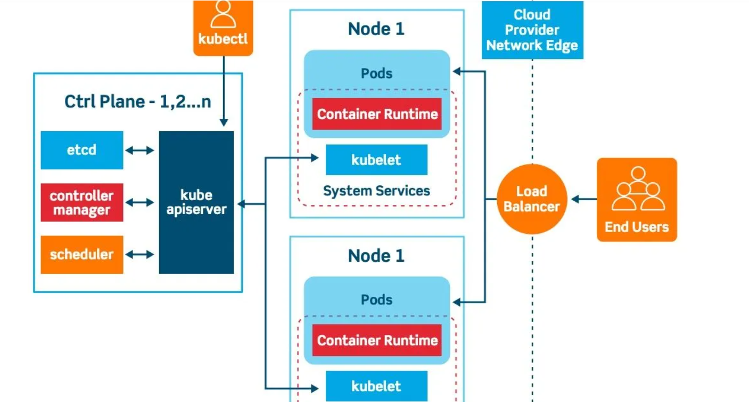
1. Control Plane Components:
The Control Plane is the brain of the Kubernetes cluster. It makes global decisions about the cluster, such as scheduling and responding to cluster events (e.g., starting up a new pod when a deployment’s replicas are unmet).
1.1 API Server (kube-apiserver):
- Central management entity and front-end of the Kubernetes control plane.
- Responsibilities:
  - Serves the Kubernetes REST API.
  - Acts as the gateway for all cluster interactions — external (kubectl, CI/CD) and internal (nodes, controllers).
  - Validates requests (authentication, authorization, admission control).
  - Converts REST requests to etcd operations.
- Scalability: Can be horizontally scaled behind a load balancer.
- Security:
  - Uses TLS for communication.
  - Implements RBAC (Role-Based Access Control) for access control.
1.2 etcd:
- Distributed, consistent, key-value store used for storing all cluster state.
- Data Stored:
  - Cluster metadata (nodes, pods, configs, secrets, roles).
  - Configuration data (ConfigMaps, policies).
  - State of workloads and services.
- Key Characteristics:
  - Strong consistency and high availability.
  - Watch mechanism: Components subscribe to changes in state.
- Best Practices:
  - Use SSD-backed volumes for speed.
  - Encrypt data at rest.
  - Regularly back up etcd to avoid catastrophic failure.
1.3 Controller Manager (kube-controller-manager):
- Runs various background controllers to regulate the state of the cluster.
- Responsibilities:
  - Continuously monitors the cluster state via the API server.
  - Reconciles actual state with the desired state by issuing API requests to update objects.
- Key Controllers:
  - Node Controller: Detects node failures.
  - Replication Controller / ReplicaSet Controller: Ensures correct pod count.
  - Deployment Controller: Handles rolling updates, rollbacks.
  - Service Account Controller: Manages service account tokens.
  - Job/DaemonSet/StatefulSet Controllers: Orchestrate non-replica workloads.
- Architecture: All these controllers are run as one process with separate threads per controller.
1.4 Scheduler (kube-scheduler):
- Assigns unbound pods to appropriate nodes based on resource availability and scheduling policies.
- Workflow:
  - Watch for new pods without a nodeName.
  - Evaluates nodes for fitness based on:
    - CPU, memory requirements.
    - Node affinity/anti-affinity rules.
    - Taints and tolerations.
    - Pod topology constraints.
    - Pod priority and preemption.
  - Binds the pod to the chosen node via the API server.
- Pluggability: Supports custom schedulers or extending with scheduling plugins.
2. Node Components:
Each Kubernetes Node (worker) runs services necessary to support containers and communicate with the control plane.
2.1 Kubelet:
- Primary node agent.
- Responsibilities:
  - Receives PodSpecs from the API server.
  - Ensures containers are running as described.
  - Monitors pod lifecycle and container health.
  - Reports status back to the control plane.
- Health Checks:
  - Executes liveness and readiness probes.
- Workload Interface:
  - Talks to the container runtime using the CRI (Container Runtime Interface).
2.2 Kube Proxy:
- Manages networking on the node.
- Responsibilities:
  - Maintains network rules via iptables or IPVS to allow pods to communicate.
  - Enables Services (ClusterIP, NodePort, LoadBalancer) by routing traffic appropriately.
  - Supports service discovery and load balancing.
- Modes:
  - userspace: Legacy; rarely used.
  - iptables: Common; simple and robust.
  - IPVS: More performant; leverages Linux kernel features.
2.3 Container Runtime:
- Software that runs containers.
- Examples:
  - containerd (most common; CNCF graduated).
  - CRI-O: Lightweight runtime for Kubernetes.
  - Docker: Deprecated for Kubernetes >= 1.24 (was replaced by containerd).
- Responsibilities:
  - Pulls container images from registries.
  - Manages container lifecycle (create, start, stop).
  - Provides stats/logs to kubelet.
3. GKE (Google Kubernetes Engine) – Special Considerations:
Google Kubernetes Engine provides a managed Kubernetes platform with two operational modes.
3.1 GKE Standard Mode:
- Traditional Kubernetes experience with user-managed infrastructure.
- Node Access: Full SSH access to nodes (Compute Engine VMs).
- Control:
  - Install custom daemons.
  - Use GPU/TPU nodes.
  - Customize node OS, networking, and security settings.
- Use Cases:
  - Complex workloads needing fine-tuned performance.
  - Security/compliance needing node-level customization.
3.2 GKE Autopilot Mode:
- Fully managed Kubernetes, optimized for ease of use.
- Node Management: Google fully manages and hides nodes.
- Operational Model:
  - Pay per pod (not per node).
  - No access to underlying VMs.
  - Automatically configures node provisioning, upgrades, monitoring, and security.
- Limitations:
  - Limited DaemonSet usage.
  - Less flexibility with custom networking/storage.
- Use Cases:
  - Rapid app deployment.
  - Cost efficiency and reduced operational overhead.
Monolithic Architecture of Kubernetes:
A monolithic architecture is a unified model for designing software where all components and functionalities are packaged into a single deployable unit.
Three-Tier Structure of Monolithic Architecture:
- Presentation Layer (Front-End)
  - Interface for user interaction (e.g., web browser).
  - Built with: HTML, CSS, JavaScript, front-end frameworks.
  - Communicates with backend via API calls.
- Application Layer (Business Logic)
  - Core processing logic (e.g., order processing, validation).
  - Written in: Java, C#, Python, C++, etc.
- Data Layer (Database)
  - Stores persistent data.
  - Technologies: MySQL, Oracle, SQL Server, MongoDB.
Deployment
- All three layers are packaged and deployed together.
- Updates require redeploying the entire application.
Example: Bookstore Web App
- Components:
  - Customer Accounts
  - Payments
  - Inventory
  - Shipping
- In monolithic style, all components are developed and deployed as one single interdependent application.
